**South Africa**

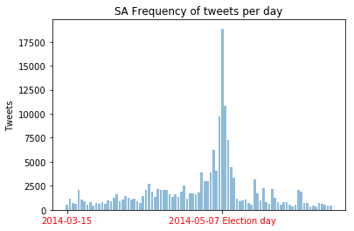

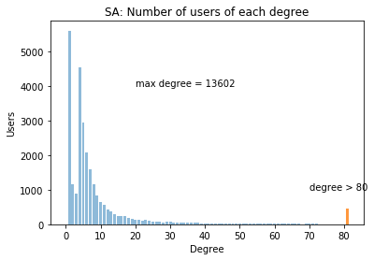

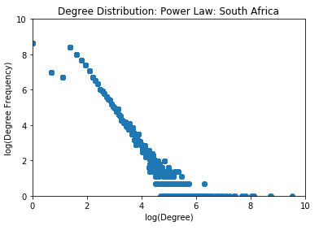

**Kenya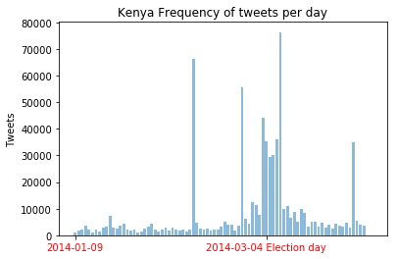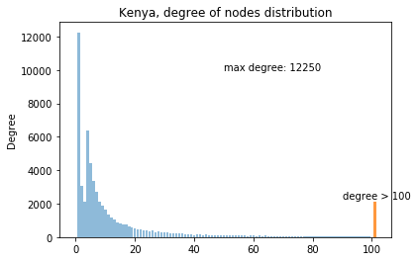**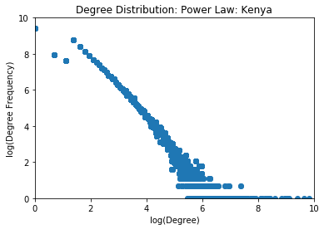

**Summary**

|  |  |  |  |
| --- | --- | --- | --- |
|  | **South Africa** | **Kenya** | **Nigeria** |
| **Tweets** | 181416 | 1135842 | 2751755 |
| **Nodes** | 26669 | 60249 | 137403 |
| **Edges** | 171685 | 694968 | 1854446 |
| **Mentions** | 370739 | 1166085 | 4516686 |
| **Diameter** | 9 | 10 |  |
| **No. Connected**  **Components** | 1 | 1 |  |
| Directed Graphs | | | |
| **Diameter** | 14 | 12 |  |
| **Connected?** | No | No |  |